**Name: Kanak Agrawal**

**Email:** [**Kanakagrawal2001@gmail.com**](mailto:Kanakagrawal2001@gmail.com)

**Date:14-02-2024**

**Day-17 Assignment (Azure)**

**Creating a Visualization**

Firstly we need to upload a csv file and create a table

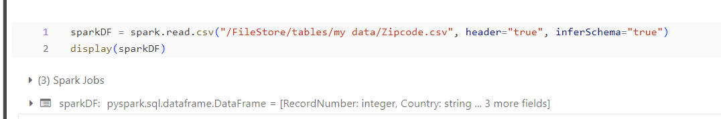

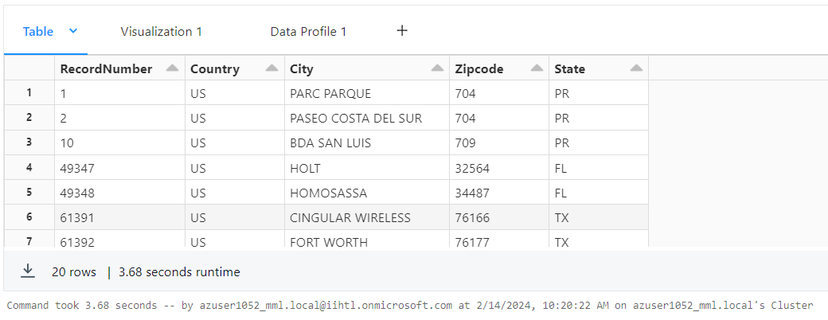

Then, Visualization

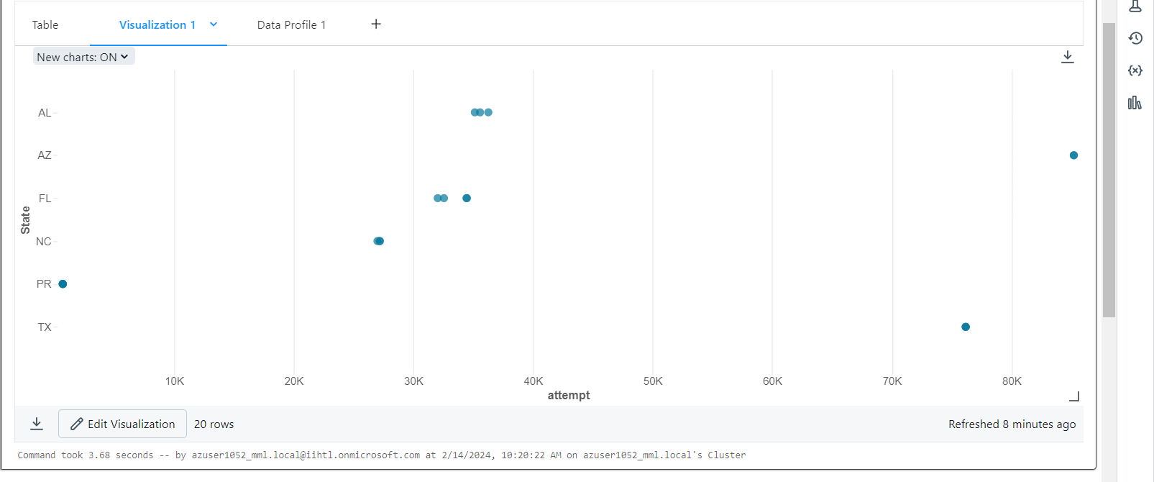

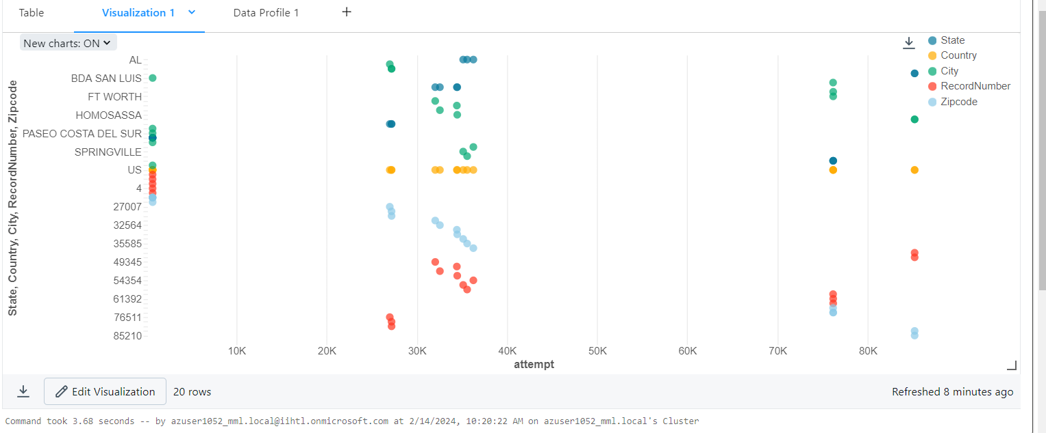

Then, data Profile

